Heart Rate Time Series Forecasting
Predicting future heart rate from continuous sensor data supports early detection of cardiac anomalies. This post outlines my approach to forecasting the next 20 minutes of Lifetouch Heart Rate.

1. Data Cleaning
The dataset contained 226 minute-by-minute observations. Eight sensor-error readings (~61,441 bpm) were identified. I replaced them using a rolling median (window=5) to reduce the impact of isolated spikes, then applied forward- and backward-fill to handle any remaining gaps. The cleaned series ranged from 106 to 172 bpm.

2. Stationarity and Validation
An Augmented Dickey-Fuller test indicated non-stationarity, supporting the use of differencing. I held out the last 25 observations for validation to approximate the 20-step forecast horizon.

3. Model Comparison
Three models were evaluated:
Model | MAE | RMSE
ARIMA(0,1,0) Random Walk | 4.88 | 6.63
Holt Linear | 5.53 | 7.65
ARIMA(2,1,0) | 5.09 | 6.91
The Random Walk (ARIMA(0,1,0)) achieved the lowest MAE. Its simplicity—differencing only, no autoregressive or moving-average terms—suited the relatively stable post-cleaning series. Holt and ARIMA(2,1,0) added complexity without improving validation error.

4. Final Forecast
The Random Walk was retrained on the full 226 observations and used to produce 20-step forecasts. The predictions stabilise around 138 bpm, consistent with the tail of the cleaned series.
Code Notebook
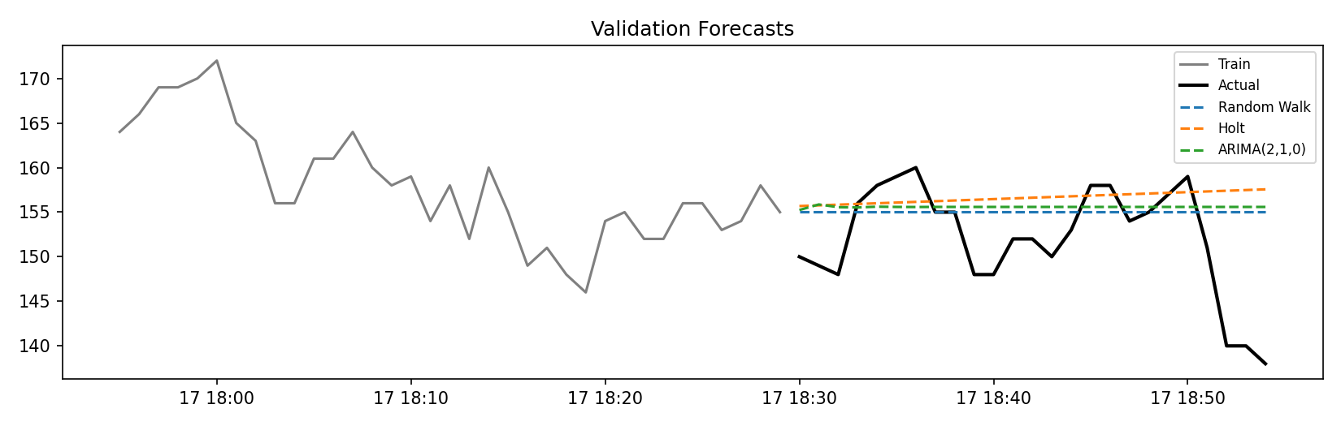
Validation Forecasts

